**My Schedule will Change**

There is a new sickness called the Coronavirus. People do not want to get sick. One way that people can try to stay healthy is by not being around a lot of other people. I need to stop going to places like movie theaters, shopping malls, and restaurants. The best way for me to stay healthy and not catch germs is to stay at my house.

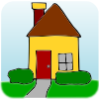 

This means that my schedule will change. People are not going to school or work right now. I will do my work at home. I may stop going to my therapy sessions for a while. Many of my favorite places to go are closed, like the Zoo and the Library. My mom or dad may work at home.

CHANGE

I can make a schedule for my day to help me know what to expect. Sometimes, things will change during the day. A place that I want to go may be closed and we will have to do something else. I may not be able to take a bike ride because it starts to rain. This will be ok. I can make a change on my schedule.

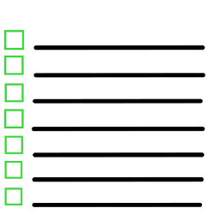 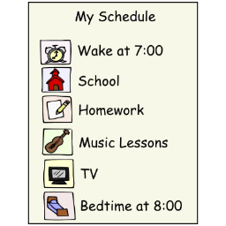

Once it is safe for people to go back to more places, I will be able to start going back to my usual schedule during the week, like going to work or sports.

